Exception
An exception is an unexpected event that occurs during the execution of a program and interrupts the normal flow of the program's execution.
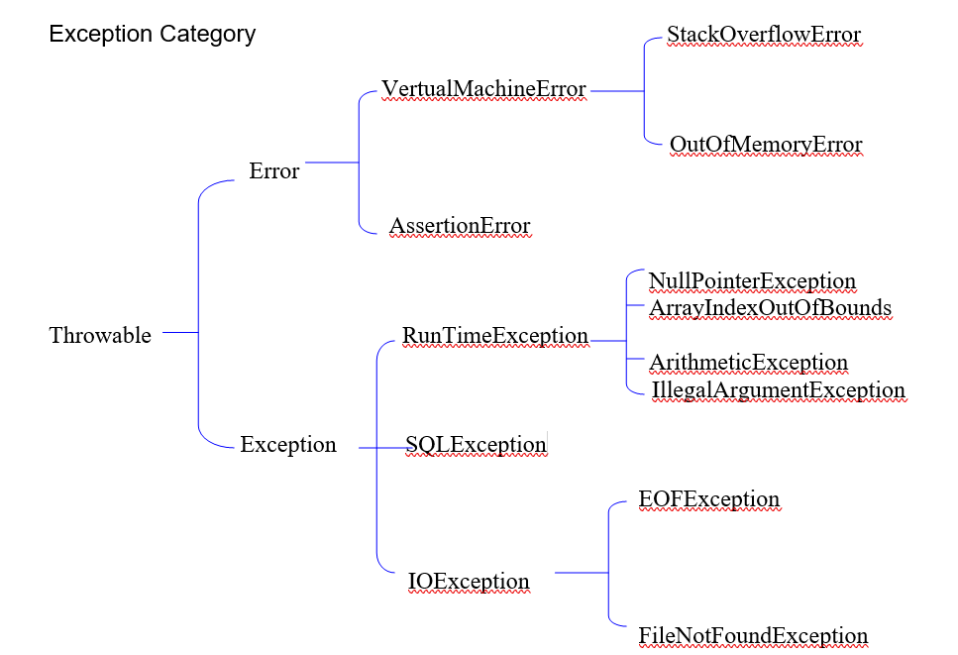
In Java, exceptions are mainly of two types:
Checked Exception
- These exceptions are checked by the compiler at compile time.
- You must handle them using try-catch or declare them with throws.
- If you don't handle them, the program will not compile.

Examples:
- IOException
- SQLException
- FileNotFoundException

Unchecked Exception
- These exceptions are not checked by the compiler at compile time.
- They occur while the program is running.
- Handling them is optional, but recommended.

Examples:
- ArithmeticException
- NullPointerException
- ArrayIndexOutOfBoundsException
- NumberFormatException

public class UncheckedExceptionsDemo {

public static void main(String[] args) {

// ArithmeticException
int a = 10 / 0;

// NullPointerException
String str = null;
System.out.println(str.length());

// ArrayIndexOutOfBoundsException
int[] arr = {10, 20, 30};
System.out.println(arr[5]);

// StringIndexOutOfBoundsException
String s = "Java";
System.out.println(s.charAt(10));

// NumberFormatException
int num = Integer.parseInt("ABC");
}
}

public class CheckedExceptionsDemo {

public static void main(String[] args) {
File file = new File("abc.txt"); // File does not exist
FileInputStream fis = new FileInputStream("D:/Books/abc.txt"); // File does not exist
System.out.println("File opened successfully.");
}
}

Exception Handling: try, catch, and finally
The mechanism for handling execeptions is embedded in the try-catch-finally construct, which has the following general form:
try { // try block
<statements>
}
catch (<exception type₁> <parameter₁>) { // catch block
<statements>
}
finally { // finally block
<statements>
}

try
- The try block contains the code that may cause an exception.

catch
- The catch block handles the exception if it occurs in the try block, preventing the program from crashing.

finally
- The finally block contains code that always executes, whether an exception occurs or not.
- It is commonly used to close files, database connections, or other resources.

Simple Way to Remember
- try → Write the risky code.
- catch → Handle the exception if it occurs.
- finally → Execute cleanup code (always runs).
Example: Unchecked Exception

public class ArithmeticExceptionDemo {
public static void main(String[] args) {

try {
int a = 10;
int b = 0;

int result = a / b;
System.out.println("Result = " + result);
}
catch (ArithmeticException e) {
System.out.println("Cannot divide by zero.");
}
finally {
System.out.println("Finally block always executes.");
}

System.out.println("Program continues...");
}
}

Example: Checked Exception

import java.io.FileInputStream;
import java.io.FileNotFoundException;
import java.io.IOException;

public class FileNotFoundDemo {
public static void main(String[] args) {

try {
File file = new File("abc.txt"); // File does not exist
FileInputStream fis = new FileInputStream("D:/Books/abc.txt"); // File does not exist
System.out.println("File opened successfully.");
}
catch (FileNotFoundException e) {
System.out.println("File not found.");
}
finally {
try {
if (fis != null) {
fis.close();
System.out.println("File closed.");
}
}
catch (IOException e) {
System.out.println("Error while closing the file.");
}
System.out.println("Finally block always executes.");
}

System.out.println("Program continues...");
}
}

Example of try-finally with an Unchecked Exception (ArithmeticException)

public class TryFinallyDemo {
public static void main(String[] args) {

try {
int a = 10;
int b = 0;

int result = a / b; // ArithmeticException
System.out.println(result);
}
finally {
System.out.println("Finally block always executes.");
}

// This statement will not execute, because the exception is not handled.
System.out.println("Program continues...");
}
}

Key Points
- try contains the risky code.
- finally always executes, even if an exception occurs.
- Since there is no catch block, the ArithmeticException is not handled, so the program terminates after executing the finally block.

Unchecked exceptions: You can use try-finally without a catch block because the compiler does not require you to handle them.

Checked Exception: A checked exception is an exception that is checked by the compiler at compile time. It must be handled using a catch block or declared using the throws clause at the time of method declaration. Otherwise, the program will not compile.

Example: Checked Exception with Catch block
import java.io.FileInputStream;
import java.io.FileNotFoundException;

public class DemoTryFinally {

public static void main(String[] args) {
try {
FileInputStream fis = new FileInputStream("abc.txt");
}
catch (FileNotFoundException e) {
System.out.println("File not found.");
}
System.out.println("End of Program.");

}
}
OR

Example: Checked Exception using the throws clause

import java.io.FileInputStream;
import java.io.FileNotFoundException;

public class DemoThrows {

public static void main(String[] args) throws FileNotFoundException {
FileInputStream fis = new FileInputStream("abc.txt");
System.out.println("End of Program.");
}
}

Note: When you use throws, you are not handling the exception. You are only declaring that the method may throw it. If no calling method handles the exception, the program will terminate when the exception occurs.

Multiple Catch Block in Java

When a single try block can throw different types of exceptions, we can handle each exception using a separate catch block.

try {
// Code that may throw exceptions
}
catch (ExceptionType1 e) {
// Handle ExceptionType1
}
catch (ExceptionType2 e) {
// Handle ExceptionType2
}
catch (ExceptionType3 e) {
// Handle ExceptionType3
}

Example:

public class MultipleCatchExample {
public static void main(String[] args) {

try {
int arr[] = {10, 20, 30};

int result = 10 / 0; // ArithmeticException

System.out.println(arr[5]); // ArrayIndexOutOfBoundsException
}
catch (ArithmeticException e) {
System.out.println("Arithmetic Exception: Cannot divide by zero.");
}
catch (ArrayIndexOutOfBoundsException e) {
System.out.println("Array Index Out Of Bounds Exception.");
}

System.out.println("Program continues...");
}
}

Multiple Exceptions Handled by a Single Catch Block

A single catch block can handle multiple types of exceptions by catching their common superclass, usually the Exception class.

public class SingleCatchExample {
public static void main(String[] args) {

try {
int arr[] = {10, 20, 30};

int result = 10 / 0; // ArithmeticException

System.out.println(arr[5]); // ArrayIndexOutOfBoundsException
}
catch (Exception e) {
System.out.println("Exception Handled: " + e);
}

System.out.println("Program continues...");
}
}

Rule

You cannot place any executable statement between a try, catch, and finally block. They must appear together as a single construct.
Incorrect Example (Compile-Time Error)

public class Test {
public static void main(String[] args) {

try {
System.out.println("Inside try");
}

System.out.println("Between try and catch"); // Error

catch (Exception e) {
System.out.println("Inside catch");
}
}
}

Nested try-catch in Java

A nested try-catch means placing one try-catch block inside another try block. It is used when different parts of the code require separate exception handling.

Example: Nested try-catch

public class NestedTryCatchExample {
public static void main(String[] args) {

try {
System.out.println("Outer try block");

try {
int result = 10 / 0; // ArithmeticException
}
catch (ArithmeticException e) {
System.out.println("Inner catch: Cannot divide by zero.");
}

int arr[] = {10, 20, 30};
System.out.println(arr[5]); // ArrayIndexOutOfBoundsException

}
catch (ArrayIndexOutOfBoundsException e) {
System.out.println("Outer catch: Array index is invalid.");
}

System.out.println("Program continues...");
}
}

Commonly Used Exception Class Methods in Java

The Exception class (inherited from the Throwable class) provides several useful methods to get information about an exception.
Method | Description
getMessage() | Returns the exception message.
toString() | Returns the exception class name and message.
printStackTrace() | Prints the exception details along with the line number where the exception occurred.

Example:

public class ExceptionMethodsExample {
public static void main(String[] args) {

try {
int result = 10 / 0;
}
catch (ArithmeticException e) {

// getMessage()
System.out.println("getMessage(): " + e.getMessage());

// toString()
System.out.println("toString(): " + e.toString());

// printStackTrace()
System.out.println("\nprintStackTrace():");
e.printStackTrace();
}
}
}

Output:

getMessage(): / by zero

toString(): java.lang.ArithmeticException: / by zero

printStackTrace():
java.lang.ArithmeticException: / by zero
at ExceptionMethodsExample.main(ExceptionMethodsExample.java:6)

